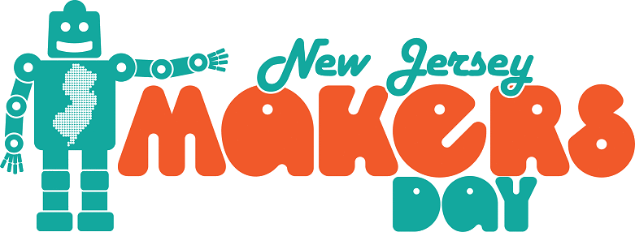

Join us on Saturday, March 23rd for a full day of maker fun for all ages!

START HERE:

** Between 10am-4pm, come to the CHILDREN’S ROOM to visit our Maker Stations for young patrons to enjoy! The stations will include: Sensory Play for our littlest visitors, Building Challenge, and Kaleidoscope Craft. All ages are welcome and no registration is required.

** Between 10am-12pm and 2pm-4pm, come to the DVD SECTION to visit our Drop-in Maker Stations for tween, teen and adult patrons to enjoy! No registration is required. (Further details below and on back.)

** Between 10am-4pm, visit the REFERENCE ROOM to relax at our Adult Coloring Station. All adults are welcome and no registration is required. Also in the Reference Room, there will be a Button Design Station – all ages are welcome, but children under the age of 10 must be accompanied by an adult. No registration is required.

HERE’S THE FULL SCHEDULE…

10am-11am

Leap into Science!
We are going to experiment with balance brought to us by the Franklin Institute's Leap into Science program! Grades K-5 Registration is limited and required. MEETING ROOM

Children’s Room Maker Stations CHILDREN’S ROOM
Adult Coloring Station REFERENCE ROOM
Button Design Station REFERENCE ROOM
See details above.

10am-12pm

Make Your Own Bath Salts Drop-in Station
Learn how to make your own bath salts at home with only 4 ingredients. Ages 12+ No registration required. DVD SECTION

Planting Tomato Seeds Drop-in Station
Come to our planting station and plant your own tomato seeds! All Ages. No registration required. DVD SECTION

Continued on the back!
11am-12pm

Website Building
Learn the basic tools and techniques you need to create your own website! Ages 16+ Registration required. MEETING ROOM

Children’s Room Maker Stations CHILDREN’S ROOM
Adult Coloring Station REFERENCE ROOM
Button Design Station REFERENCE ROOM
See details on reverse.

1-2pm

Harry Potter Wands for Tweens and Teens
Come and pick your Hogwarts House and find out how you can make an LED light up on the end of your wand. Grades 4-12 Registration is limited and required. MEETING ROOM

Children’s Room Maker Stations CHILDREN’S ROOM
Adult Coloring Station REFERENCE ROOM
Button Design Station REFERENCE ROOM
See details on reverse.

2-4pm

Stamp Carving Drop-in Station
Learn the basic steps to carve your own fun stamp to take home! Ages 10+ No registration required. DVD SECTION

Beaded Bookmarks Drop-in Station
Make your own beaded bookmark! Ages 12+ No registration required. BALCONY

Morse Code Bracelets Drop-in Station
Make a bracelet featuring your own secret message in Morse Code! Ages 10+ No registration required. DVD SECTION

Children’s Room Maker Stations CHILDREN’S ROOM
Adult Coloring Station REFERENCE ROOM
Button Design Station REFERENCE ROOM
See details on reverse.

2:30-4pm

Robots!
We’ll be looking at several of the library's robots and what they can do before getting up close and personal with some hands-on time! Ages 10+ Registration required. MEETING ROOM

Along with all of this fun maker programming, we will have raffles throughout the day! Don’t miss this great opportunity to participate in STEAM activities along with more than 250 libraries, schools and maker spaces all over the state!
Matawan Aberdeen Public Library
165 Main Street, Matawan – www.matawanaberdeenlibrary.com

