THE MATAWAN-ABERDEEN LIBRARY IS PARTNERING WITH LOCAL BUSINESSES TO HELP SUPPORT THE SHOP SMALL EFFORT ON SMALL BUSINESS SATURDAY!
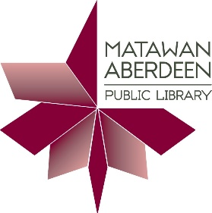
Visit any of these participating businesses from 11/25 – 12/2 and show your MAPL library card to earn 10% off your purchase!
Angelo’s Pizza & Sub Shop, 321 Broad Street
Bart’s Restaurant, 74 Main Street
Benedetta’s Pizzeria Restaurant, 39 Mill Road
Bird Lover’s Paradise, 32 Main Street, Unit 5A
Boost Mobile, 114B Main Street
Chicken Holiday, 307 Broad Street
Cut & Curl Hair Salon, 334 Main Street
El Rinconcito de Mama Restaurant, 129 Main Street
Hair Central Salon, 2 Main Street
Hair of the Dog, 1 Ravine Drive
Jersey Mike’s Subs, 251 Main Street
Matawan Bakery, 319 Broad Street
No. 1 Chinese Restaurant, 134 Main Street
Tiffani’s Vintage Closet, 154 Main Street

