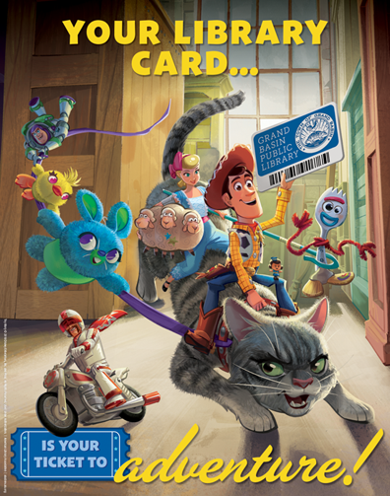
SEPTEMBER IS LIBRARY CARD SIGN-UP MONTH!
Celebrate with us!

Throughout September, anyone who signs up for a new card will be automatically entered to win a Main Street Gift Card Prize Pack. The pack includes $25 gift certificates to The Geekery, Verucastyle, Maloney's, and Papa Ganache. One lucky winner will be chosen in early October.

We will have Free Book Fridays in September! There will be a table set up outside on the porch where patrons are free to take a book (or more than one) from 10am-5pm.

Where in the community is Kimberly Paone? Our Library Director will be popping up in different places around the towns during the course of the month - if you can show me your library card, you will win a prize.

Our New Residents' Reception will be held on Friday, September 27th from 7-8:30pm. New residents are invited to come to meet staff members, get a card, take a tour of the building, enjoy refreshments, play in the children's room, and enter a raffle.

Check our Facebook page, or ask a staff member for more details!

