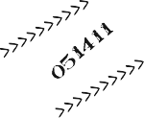

ARE YOU NEW IN TOWN?
YOUR LIBRARY WANTS TO WELCOME YOU AT OUR
NEW RESIDENTS' RECEPTION!
09.277.-81:309PM
MEET SOME OF THE STAFF, TAKE A TOUR, GET A LIBRARY CARD, AND HAVE SOME REFRESHMENTS!

THERE WILL BE RAFFLE PRIZES AND
FUN FOR THE KIDS...

WE HOPE TO SEE YOU THERE - BRING YOUR FAMILY AND FRIENDS!

MATAWAN ABERDEEN
PUBLIC LIBRARY

165 MAIN STREET (PARKING IN BACK)
MATAWAN

